Task 7

**Project overview:**

I had taken my previous example of pantaloons application

**Problem Statement:**

* Small text size
* Difference between item info card background and main screen background
* CTA button

**Research Insights:**

* Background color
* Font style
* Font size

**WireFrames:**

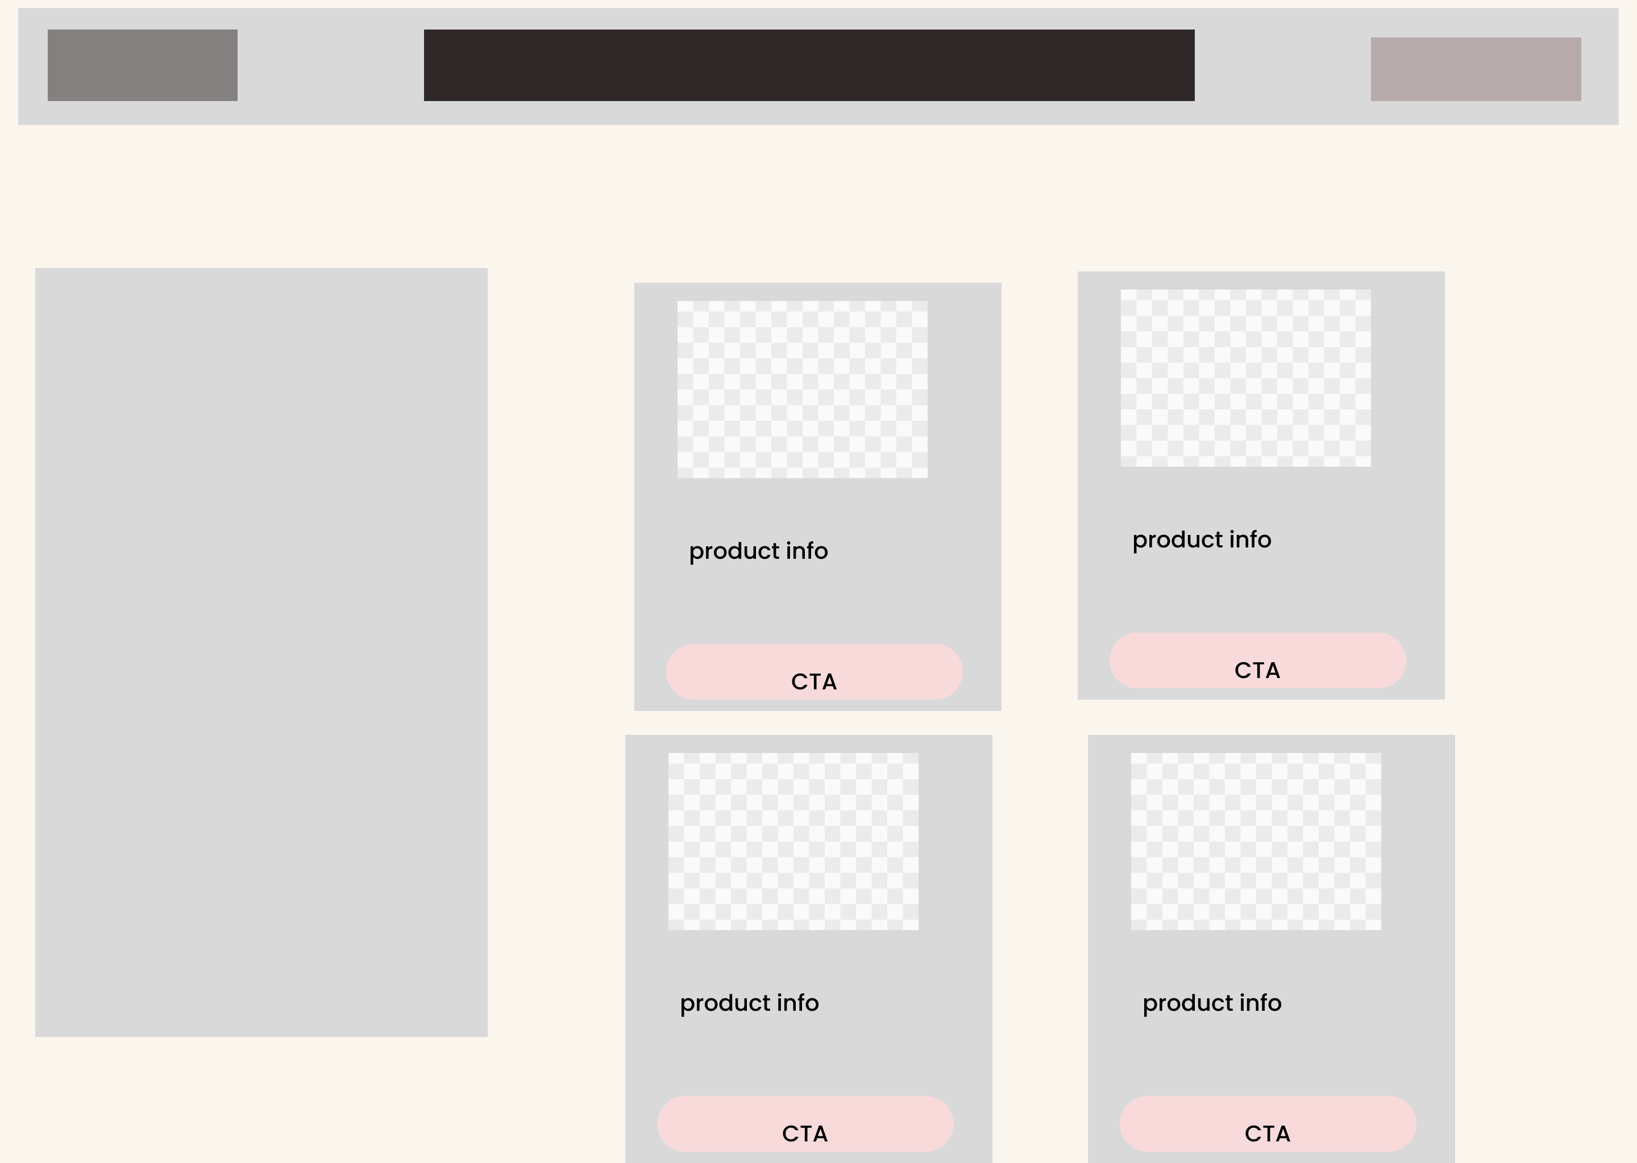

**Final UI Screen:**

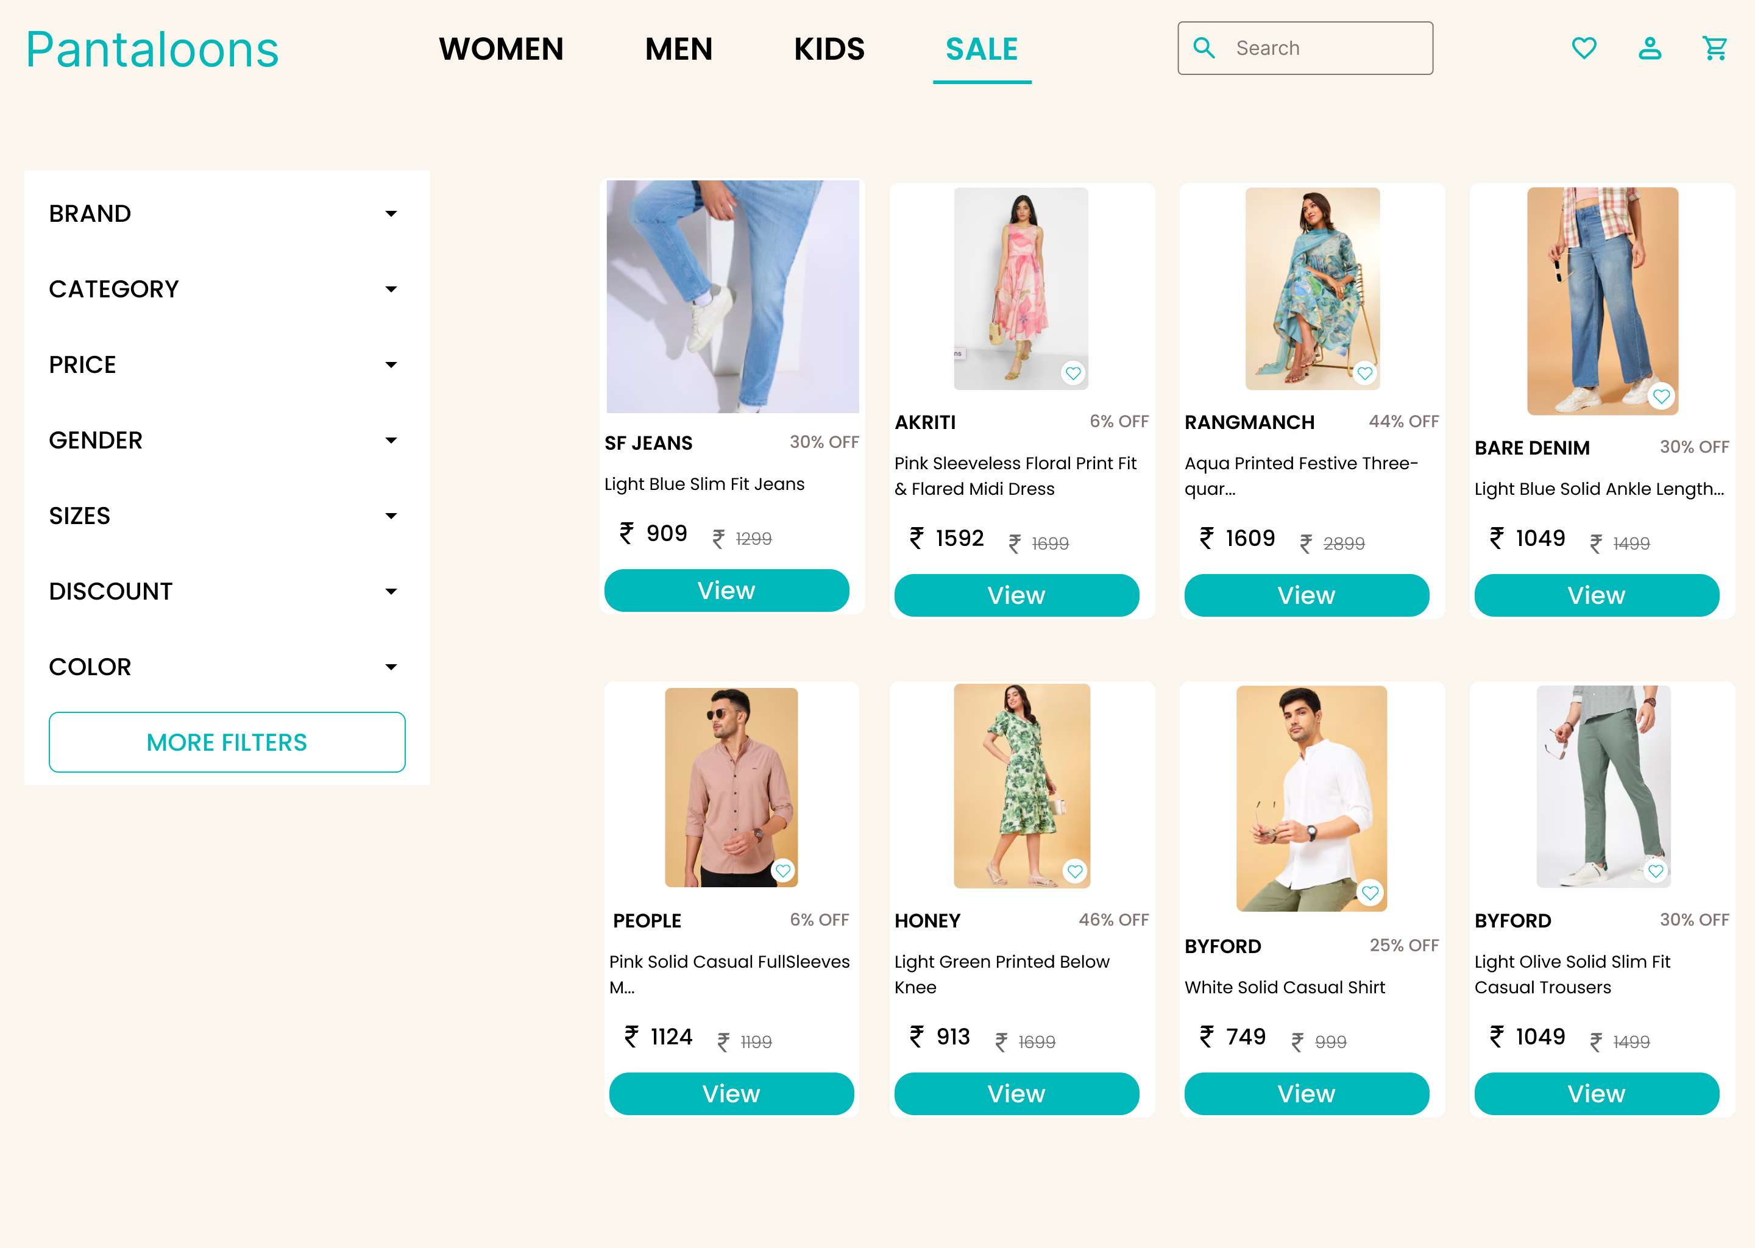

**Conclusion:**

i had increased the size of the text. Added the CAT button in the item card itself  
differentiated between the background of the card and the background og the screen  
  
so that the user can navigate easily

**Figma**

**https://www.figma.com/design/0QeD2QAGsuzneeimEEfctB/Elevate-labs?node-id=93-493&t=YTOZDww7TanKgshJ-1**